4.s42 // MIT Spring 2018
Collaborating Across Disciplines: Architects and Engineers

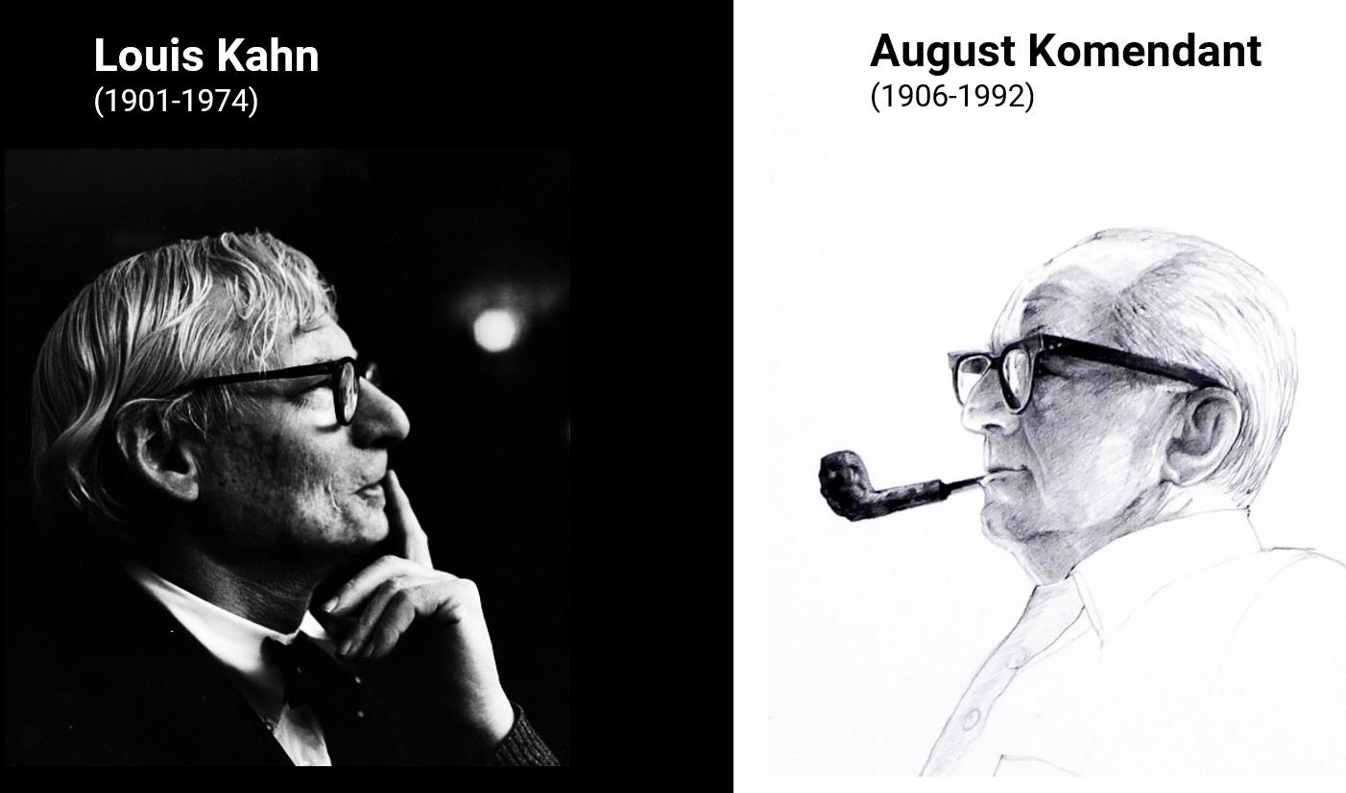
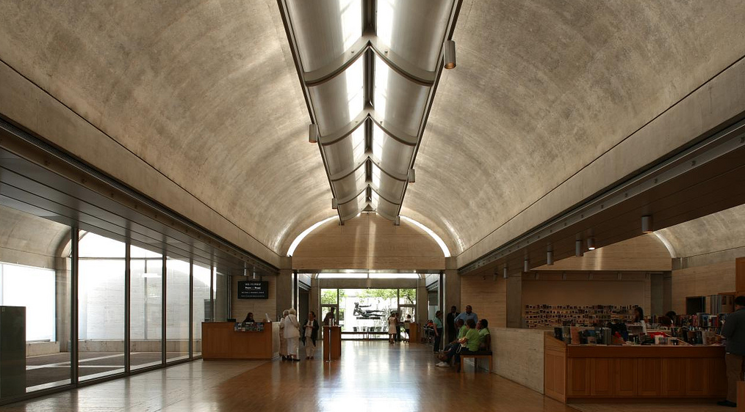
Kimbell Art Museum in Fort Worth, TX, completed in 1972

Instructor // Caitlin Mueller, caitlinm@mit.edu
TA // Irmak Turan, ituran@mit.edu

Meetings // Tuesdays, 9-12 in 5-415 (enter through 5-418)
Units // 3-0-6

Subject description //

Design in the built environment necessarily entails collaboration across disciplines, especially when there are aspirations for innovation in geometry, materials, and construction technologies to support and contribute to an architectural vision. Indeed, many of the most significant achievements in buildings have been empowered by important and synthetic contributions from architects and structural engineers working together closely. In 4.s42, we will critically examine key characters in collaborations of these types, investigating their relationships, communication styles, tools, design processes, and legacies.

We will focus specifically on ambitious reinforced concrete architecture of the 1950s-1970s from around the world, which includes diverse formal development and structural innovation, from thin concrete shells to complex space frames to soaring spans. This time period also marks a fundamental shift in available tools and calculation methods for engineers, with the development of finite element analysis and related computational techniques. Our goal is to extract examples and principles of productive collaborations from this context and consider how they might be applied going forward.

Each student will take on an individual architect-engineer pairing to study in detail in a semester-long research project. Possible pairings include Eero Saarinen and Abba Tor, Louis Kahn and August Komendant, Kenzo Tange and Yoshikatsu Tsuboi, Jørn Utzon and Ove Arup, Lina Bo Bardi and José Carlos de Figueiredo Ferraz, Oscar Niemeyer and Joaquim Cardoso, and many others that we will discover together (If you do not recognize the second names in the above pairings, it may be a sign that you have more to learn about engineers!).

At the end of the semester, we will assemble an anthology of collaborations with a written contribution from each student, along with a final presentation. The class will meet once weekly for a three-hour period, which will include lectures, discussions on readings, and progress updates from students on individual projects. Graduate and advanced undergraduate students from Architecture, Civil and Environmental Engineering, and related disciplines are welcome. Enrollment limited.

Schedule and Deadlines //

Meeting Date Topic
01 February 6 Introductory lecture: Architect-Engineer collaborations
02 February 13 Students present: Collaboration data
- February 20 No class / Monday schedule
03 February 27 Students present: Project proposals
04 March 6 Discussion topic: Reinforced concrete principles
05 March 13 Discussion topic: Concrete typologies and systems
06 March 20 Students present: Interim project presentations
- March 27 No class / Spring vacation
07 April 3 Discussion topic: Formwork, casting, and prestressing
08 April 10 Discussion topic: Engineering calculations and tools
- April 17 No class / Patriots Day vacation
09 April 24 Discussion topic: Future of collaboration
10 May 1 Students present: Final project presentations
11 May 8 Students present: Final project presentations
12 May 15 Final papers due

* Readings will be assigned on a weekly basis.

Expectations and Grading //

Attendance and participation: 20%
Collaboration data: 10%
Project proposal: 10%
Interim presentation: 10%
Final presentation: 20%
Final paper: 30%

