4.144 + 4.154 Architectural Design Option Studio
Spring 2018

Andrew Scott + John Klein
TA: Chris Weaver
Tuesday / Thursday 1.00 - 6.00

MASS TIMBER MID-RISE
Integrated Ecosystems for the Future of Urban Living
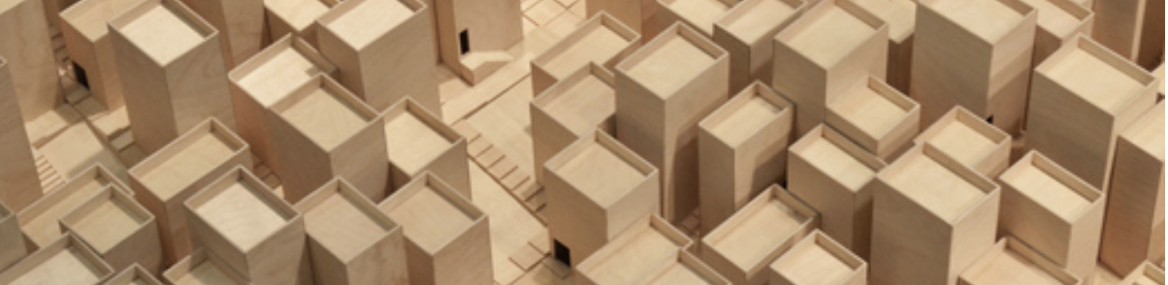

Introduction
Significant economic, environmental and development demands are being placed on many coastal US cities from exponential population growth, demographic change and climate adaptation. Within these scenarios, the issues of urban health, ecology and resources, and housing affordability remain as major design challenges. In particular, the tight housing market, as seen in Boston and other major US cities, is highly affected by ongoing residential price inflation which, in turn, calls for more design innovation in the typologies and figurations of urban housing models. At a moment when cities face these dramatic shifts, innovating and testing ideas for new green urban hybrid housing is more essential than ever.

Taking this scenario as the broad context for design, the studio will work with two major pedagogical axis:

Firstly, responding to the case for housing demand, the studio will engage in the research and design development of hybrid urban housing types for a new urban economy. Projects will take on issues such as: hybrid programs to sustain the activities such as of health /work /play /art; the notion of sharing versus ownership; micro versus macro scales of habitable space; questions of urban density, physical mass and formal figuration; and the means to make development self-sufficient in resources and energy. The integration of these design agendas will begin to define new scalable prototypes for city living.

Secondly, with the rise of the Mass-Timber movement in North America, developers, manufacturers, federal and local governments, are turning towards this timber based design and construction technology as a potential solution for affordable and sustainable housing in cities. In Boston in the development sector there is interest in the work of the studio that may inform future urban projects. Mass-Timber can also enable the creation of lighter, carbon-negative buildings to sustain more economical increased densities in waterfront contexts. The studio will explore new models of mid-rise affordable housing that utilize mass-timber technologies, and in parallel investigate design innovations in digitally prefabricated solutions engaging volumetric + flat-pack hybrid assemblies.

The locational context for the studio will be different adaptable urban waterfront sites in Boston harbor context where the interface as the constructed edge between water and land has a rich and progressive history of development both as land infill and as land transformation. There will be scope in studio design projects for rethinking the relationship between land and architecture- and housing form as a scalable figure with public space. While the new demands for design ‘resilience’ have to be accommodated as design parameters for the future impacts of climate change, certain urban edges and piers also call for rethinking the nature of place, urban landscape and associated infrastructure.

There will be a studio travel trip to Helsinki, Finland over the Spring Break (March 22-28). This expedition is intended to broaden the knowledge of both Mass-Timber applications and technologies – and also to experience bold ideas in the planning of waterfront projects. The studio will learn first-hand about sustainable forestry practices and timber manufacturing processes. In addition, connection will be made with a local university school, and visits will be made to notable built architecture projects in Helsinki and the region. The travel for the studio is being sponsored by MetsaWood, an international timber company based in Finland.

Process and Exercises
The format for the studio will be a series of research and design exercises that will progressively develop a deeper understanding of the context of the design assignment through research and experimentation, design development and testing through drawings and prototypes.

Broadly speaking, the semester will be divided into two distinct segments with the division being Spring break and the Finland trip. The first half of the semester will be about research, ‘play’ and conceptual development. The ethos of the studio is to do these simultaneously so that they inform each other. Students will be engaging research as an agency towards design thinking, to find information that is essential for designing, and to assemble it in a format that all students can share. The aspect of ‘play’ is to engage directly in outward design thinking through physical experimentation on mass, scale and typology. The conceptual exercise will be an engagement with the agenda / brief of the design project – and to make a proposition about an architecture that can be defined in multiple ways (community, organization, environment, scale and mass, spatially, materially etc). The development and ‘fleshing out’ of this concept will be into two stages with pin-ups and critique between so that ideas can be adjusted and refined. At the Spring break, the expectation is that students will have an emerging project that has a clear strategy that can be articulated through a series of sub-concepts or ideas.

The second half of the semester, will be about refining ideas, and the architectural operations of the design projects. Each project will likely have a particular characteristic or issues that needs further exploration and development that is seen as critical to the architecture. Therefore, through drawings and the making of physical prototypes, exercises 3 and 4 will test out and integrate the materiality and construction as well and other critical systems of the design project.

See the studio schedule for more specific weekly activities.

Throughout studio, there will be a series of visitors who will be giving various talks on topics of interest to the studio, related to timber, Boston development and housing. There may also be a local trip to visit a timber prefabrication facility in New Hampshire.

The final review for the studio is likely to be Tuesday May 15.

Studio trip
The studio trip to Helsinki, Finland will be over the Spring break, and likely March 22-28. While not compulsory, students are strongly encouraged to participate. MIT will cover the cost of economy fare flights to Helsinki and stay in a local tourist / business hotel with students expected to share rooms (2 per room). Students are expected to pay for their own meals and drinks- and other personal expenses while in Finland. The trip will include meeting with local industry firms, visiting a timber mill, visiting local architectural venues and possibly collaborating with students from the Aalto University on a design or technical exercise. Further details will be issued be during the semester and closer to the date of travel.

Evaluation Criteria
Students are expected to make a continuing and positive contribution to the culture and discourse of the studio and engage in general discourse, which will be taken into account in the evaluation of grade for the studio. The evaluation of performance in the studio will be divided between major exercises during the studio – and the capability to develop, present and discuss a comprehensive body of work at the final review. Generally, 40% of the grade will be for assignments and exercises during the course of the studio-­‐ and 60% assessed on work at the conclusion of the studio. However, students should understand that these two elements are interwoven and so the final grade will also reflect a comprehensive valuation of the work of the student during the whole semester leading to a final project. Students will also be issued with advisory comments on their progress and development at or around the ‘mid-­‐term review’ stage of the studio (likely in the second half of the semester).

Learning Objectives
The ability to research, conceptualize, develop, represent and communicate a complex architectural project. To theorize and evaluate strategies, and to be able to translate these into physical and formal design organizations. To understand the complexities inherent in designing with the existing urban fabric, and to integrate concepts relating to urban ecology and sustainability. To develop macro and micro scaled design concepts that are fully integrated and related through the design project. To deploy a variety of 2d and 3d media, techniques and simulations in support of the goals of the design project

Studio Culture
A positive, active and lively culture in the studio is important and therefore regular attendance in the studio is required, and participation in the discourse of the studio is essential. It is expected that all students will work in the studio at all times. Students must commit to the incremental development and iteration of their work on a regular basis (i.e. daily). The project work will call for a high level of collaborative discussion and problem solving whether working on individual projects or on a team basis. Absences from studio for medical reasons or otherwise should be notified to the instructor or TA as soon as possible.

