SOFT COLLISION
A research workshop with Anton Garcia Abril and Mark West

4.181 Building Invention
Where: PopLab and N51/IDC workshop
When: Wednesdays, 2:00-5:00
Credits: 9 Units
Prerequisites: permission of instructor

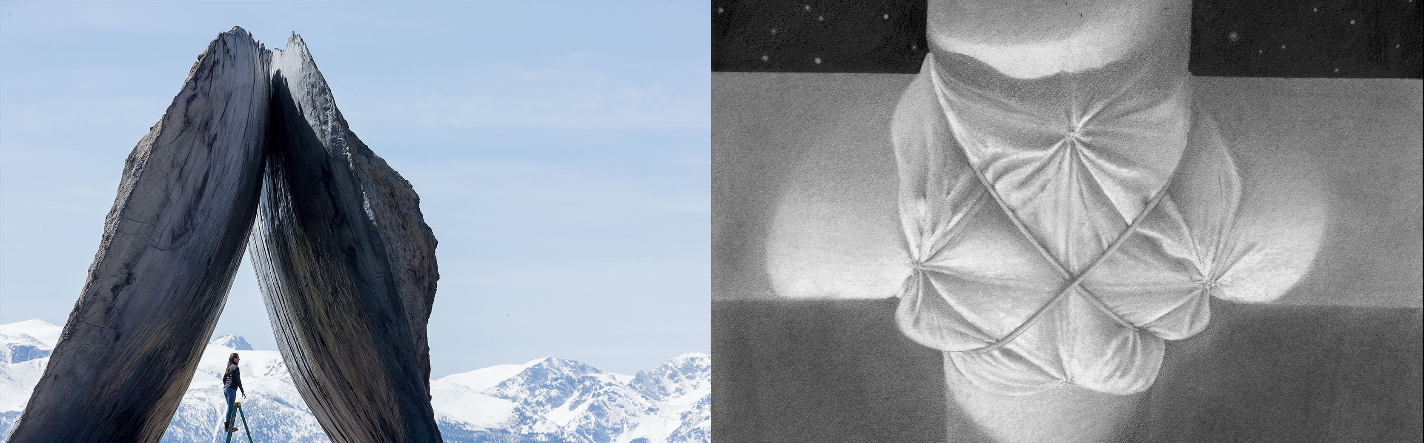

This workshop will explore some unsolved problems of fabric-formed concrete. We will do this by building small-scale physical models and full-scale tests of formwork ideas. The models will be made as miniature, analog, constructions, allowing us to scale them up to test our findings in full-scale prototypes. The specific subject(s) of our work, outlined below, may be tackled individually or as a single, complex, question.

This is a hands-on class that will meet in the PopLab and the N51/IDC workshop space (depending on the phase of the work). Here we will search (physically) for new ways to build, and reflect upon the new sculptural and architectural forms that emerge from our work.

The class is open to architecture and engineering students, both graduate and undergraduate. Prior building experience, although useful, is not required.

SUBJECT & METHOD OF WORK:

Focus 1. The Ugly -- The Beautiful

Fabric moulds for concrete structures allow an entirely new, and largely unexplored, architectural "language" to emerge. The flexibility of these moulds naturally produces forms, details, and ornamentation that are extraordinarily elegant but they may, just as easily, produce forms that are tremendously ugly. Victor Hugo has this to say about ugliness:

The Beautiful has only one type: the ugly has a thousand. This is because the beautiful, speaking humanly, is nothing but form considered in its simplest relation, its most absolute symmetry, its most intimate harmony with our organism. Therefore it always offers us an ensemble that is complete but limited as we are. What we call the ugly, on the contrary is a detail of a larger ensemble which escapes us, and which harmonizes not with man, but with entire creation. That is why it presents us forever with new but incomplete aspects.

-- Victor Hugo from the Preface to 'Cromwell'

When architecture has looked to Nature for inspiration it has, almost universally, fixated on a certain kind of beauty exemplified by flowers, leaves, branches . . . (think of any classical architecture for example). These are all forms of life bathed in light. But below this is the soil, complexly built from decay, where the roots live. We think this "darker", and more complex side of beauty deserves to be studied, not simply in terms of its potential aesthetic charge, but because we think that here we may find new and strangely elegant ways of solving some difficult construction problems.

Focus 2. Flexible Moulds For Concrete Frames

Textiles have been used for many years to form concrete structures in a wide range of applications, but there is one very basic application that still presents some tricky problems -- the construction of frame connections between columns, beams and slabs. Fabric moulds provide extraordinarily efficient and low-cost ways of constructing these structural members, but details of how to join them together into three-dimensional structural frames still present some difficult problems that are not well solved (yet). This soft 3-D puzzle involves a certain kind of geometry, but it is also a construction problem as well as a sculptural problem involving the invention of a new sculptural and architectural "language" for concrete structures. In this class you will have the opportunity to contribute directly to advanced research in this field.

Class Structure

You will not only build things in this class, you will also be drawing and recording your discoveries (and perhaps those of your colleagues, where they intersect with your own work) in a technical portfolio. Although your work may be done in small groups or with partners, each student will make an individual portfolio, which will serve as the final product and hand-in for the class, and the basis for your evaluation (see Evaluation below).

In any event, we consider the class as a whole to be a collective engine of ideas. We are not so interested in the individual “authorship” of ideas as we are in cooking up something really interesting and valuable together. If one of your classmates (or critics) comes up with an idea you can use in your own work, you are entirely free to use it without embarrassment, and visa versa (of course with proper credit given). In other words, even as you are responsible for your own individual work, our work together will be structured as a collective commons.

The research method at work in this class is research through discovery and invention. This is, by its nature, a messy enterprise that requires mistakes. Consider it an adventure with an unknown conclusion. Your role needs to be a very active one – what you produce each week will fundamentally form the content of the class, serving to guide our discoveries and conversations together.

We know that ideas come more easily when the work is pleasurable, and we hold this to be a central part of our relations with you. Yet what we are proposing is also quite serious, and we expect a commensurate seriousness and dedication to the work at hand. We are giving you fundamentally difficult problems to grapple with, and while we expect the work to be fascinating, we also expect it to be deliciously difficult. We will offer you guidance where it is needed, but also enough freedom to get yourself into some really interesting trouble.

Technical Portfolio

As you proceed, you will record and compile your work (including your troubles and failures) in an individual technical portfolio. These will be submitted after the workshop’s final reviews, to be used by us to evaluate your work. Collectively, the portfolios will also form a library of ideas and solutions for others to refer to going forward. Part way through the class (Nov. 2) you will submit your portfolio for an interim review were we can discuss your work’s progress, the state of the portfolio, and how you are doing in the class.

Again: we understand that this kind of creative technical invention nearly always turns on mistakes. Failures are truly welcome, as there is nothing more valuable than a really high quality failure. So it is crucial for you to critically record both failures and successes in your Research Portfolio.

Portfolio Format:
You will submit one 11” X 17” Tabloid format paper copy and one digital (PDF) copy of the portfolio, along with other relevant digital files (virtual models, videos, etc.).

Evaluation

- There are no exams.
Your final grade will be based:
- 25% on the quality of your participation in the class (as a research collective), and
- 75% on your individual Research Portfolio
Your final grade will be determined by both teachers of this class together.

------------------------------------------------------------------------------------------------------------

CLASS SCHEDULE:
Wed. SEPT. 7 First Class: with Mark West and Anton Garcia Abril
Wed. SEPT. 14, 21 With Anton Garcia Abril
Wed. SEPT. 28 With Mark West
Wed. OCT. 5, 12 With Anton Garcia Abril
Wed. OCT. 19 -- DEC 14 With Both Mark West and Anton Garcia Abril
OTHER IMPORTANT DATES:
Wed. NOV. 2 Interim Portfolio Review
Wed. NOV. 23 Drop Date
Wed. DEC. 14 Final Reviews
Note that The Final Review is not where your work is evaluated. In this class, formal reviews are strictly conversations about your work and the class’s work (see Evaluation below)
Mon. DEC. 19 FINAL PORTFOLIO SUBMISSIONS
(see the Technical Portfolio description above)

